React-Native Day4

- Add profile picture
- 

- Use AsyncStorage To Add Product To The Cart and display the at cart screen
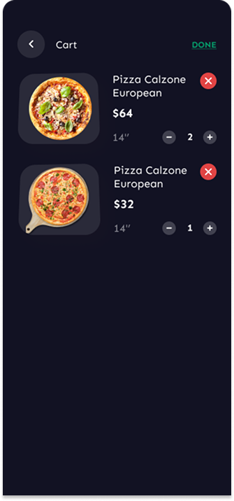

2-handle Theme Feature using Context. (bonus)
- Build your app on expo (bonus)

